**LIT ASSIGNMENT -DAY 11**

**Name : Bharat Pratap Singh**

**EMPLOYEE ID – 46255429**

**Exercise 1 – Creation of Smartform.**

1. Using smartforms tcode, created smartform as per given requirements.

* Logo window.
* Address window.
* footer window.
* page numbers window.
* Main window.

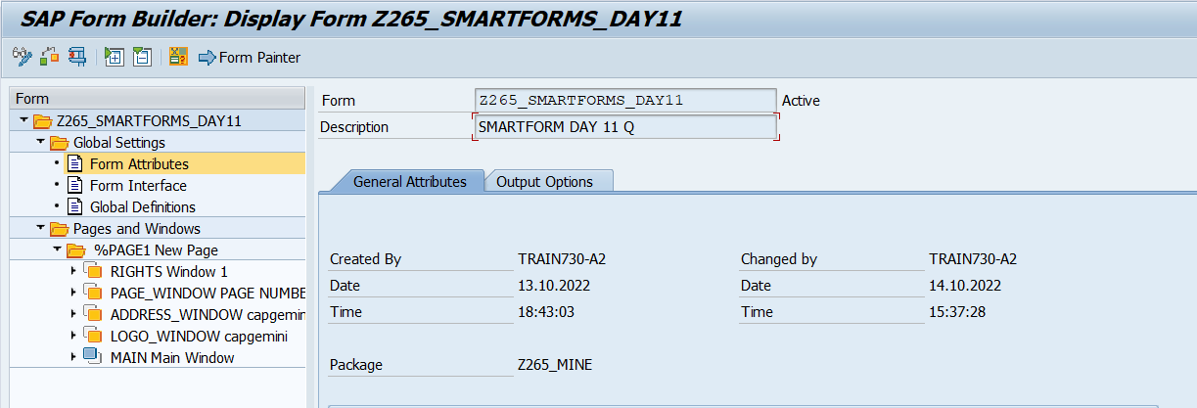

2. using Form painter, we can design layout using drag and adjust method.

3. Designed layout according to given measurements.

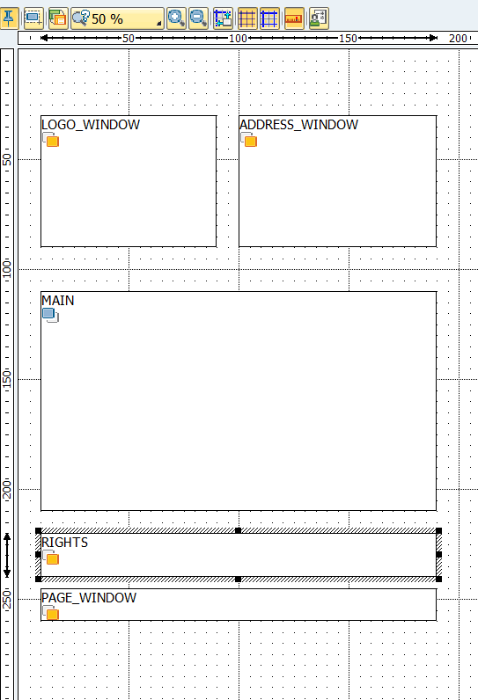

4. Created table in main window.

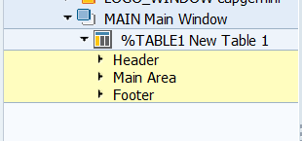

**Exercise 2 – Creation of Smart Style**

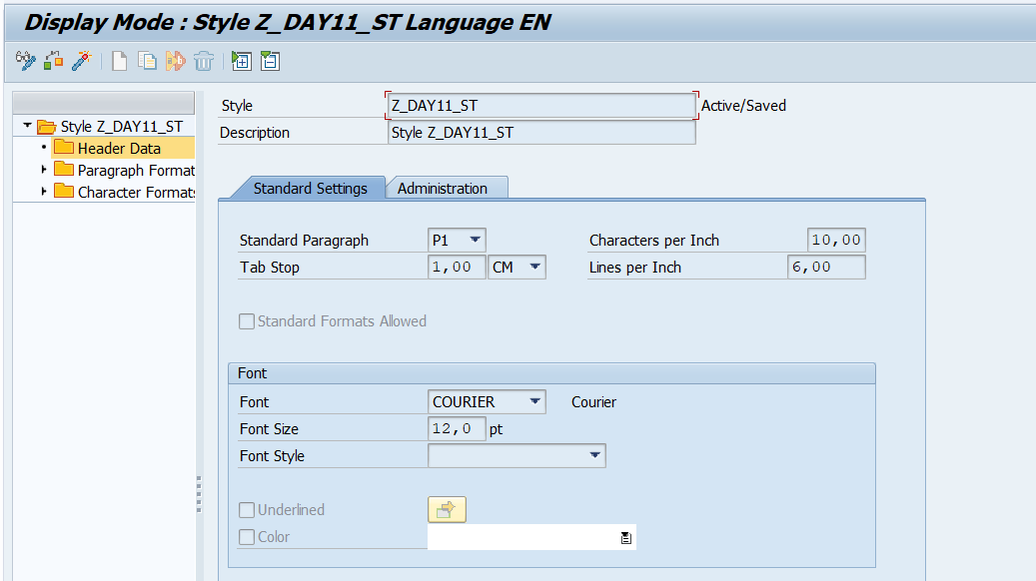

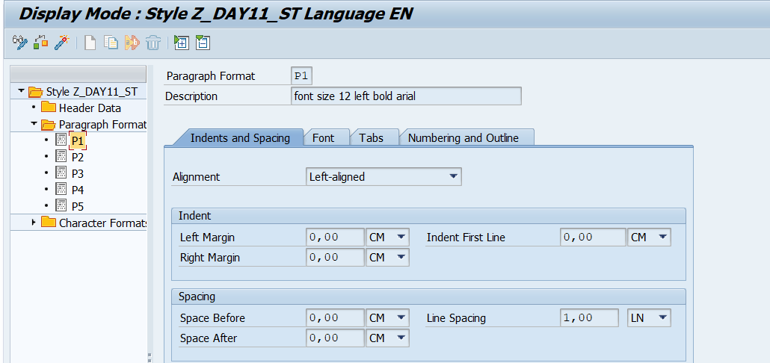

**Exercise 3 – Calling Smartform from the ABAP driver program .**

Code:

*\*&---------------------------------------------------------------------\**   
*\*& Report Z265_DAY11_SMARTFORMS*   
*\*&---------------------------------------------------------------------\**   
*\* Description:  smartforms                                                       \**   
*\*                                                                      \**   
*\* Author:  Bharat Pratap Singh                                                           \**   
*\*                                                                      \**   
*\* Create date:  13-10-2022                                                       \**   
*\*                                                                      \**   
*\*&---------------------------------------------------------------------\**   
*\* Modification log:                                                    \**   
*\* -------------------------------------------------------------------- \**   
*\* Date        User name      ID       Change Request   Case ref.       \**   
*\*             Description                                              \**   
*\*&---------------------------------------------------------------------\**   
REPORT Z265_DAY11_SMARTFORMS.   
tables: Z11DATA.   
   
data LV_FM type RS38L_FNAM.   
   
types: it_emp type table of z11DATA.   
data: it_emp1 type it_emp.   
   
select *   
from Z11DATA   
into table it_emp1.   
   
  cl_demo_output=>display( it_emp1 ).   
   
   
CALL FUNCTION 'SSF_FUNCTION_MODULE_NAME'   
    EXPORTING   
      formname                 = 'Z265_SMARTFORMS_DAY11'   *"formname*   
   IMPORTING   
     FM_NAME                  = lv_fm.   
   
  IF sy-subrc <> 0.   
   
  ENDIF.   
  call function lv_fm   
  exporting   
    it_emp             = it_emp1   
   EXCEPTIONS   
   FORMATTING_ERROR           = 1   
   INTERNAL_ERROR             = 2   
   SEND_ERROR                 = 3   
   USER_CANCELED              = 4   
   OTHERS                     = 5.

Form Output:

